ATTENDEE CHEAT SHEET

What to expect as an attendee at our Virtual Conference

We are excited to have you as part of our virtual conference experience. Below is a list of important items to watch for, steps for the day of the event, and our recommended best practices.
Accessing the Platform:
To access the virtual conference, go to: www.virtualeventplace.com/AAGC2020
Click the LOGIN or SIGN UP – IT’S FREE button.
On the Login for Existing Users tab, click the Forgot Password? hyperlink and enter your email address.
You will receive an email with your password to log into the site. *This email will be coming from info@virtualeventplace.com.
When you first log-in, you will be prompted to change your password.

Once you change your password, in the upper right, click on ‘My Virtual Events’. Then click on ‘AAGC2020’. This will bring you to the lobby of the event.

Test your event access and come early on show day
Everyone hates technical difficulties. And since your computer and internet connection are important to attend the show, let’s make sure you’re set up correctly before the show starts. We set up a DEMO SHOW for you to test out your computer or phone compatibility. You don't need to download anything, including special software. The show platform will work on all current browsers, but works best in Firefox.

Check out the DEMO SHOW by visiting www.virtualeventplace.com/demo (open daily 9am - 5pm EST)
Editing your profile:  To ensure that your profile is complete and accurate, simply select Update My Profile from the drop down menu under your photo icon in the upper right corner. Be sure to click Save at the bottom of the screen. You can view your changes by clicking on My Profile at the top of your screen on the right hand side.  IMPORTANT: Please DO NOT update your email address. This is how you authenticate yourself to login for the event. If you change this field it may cause login issues in the future.  Event Functions & Navigation  You will be landing in the event lobby. From here you can navigate to the various room of this event by clicking on the room title (eg. Networking Lounge) or by clicking on the room title at the top of the screen. | 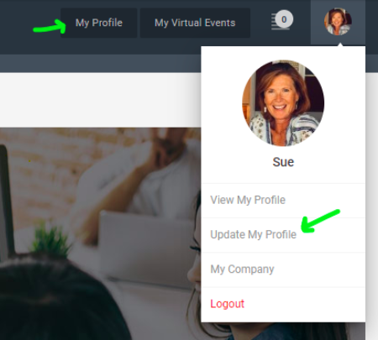
Test the video chat and the text chat (private or public) feature in the Virtual Event Place Booth. You need to enable camera and audio controls for your computer.

Also stop by the Programming auditorium and start a session or visit https://zoom.us/test. This lets us know if you can get into a Zoom meeting (where sessions will be hosted). If you are having problems accessing Zoom on your computer, please try accessing Zoom on your cell phone or another smart device.

Be sure to swing by the booths in the Exhibitor Hall where you can engage in conversation using the chat. Don’t have time to engage in conversation, click on Leave a Business card so that Exhibitors may follow up with you.
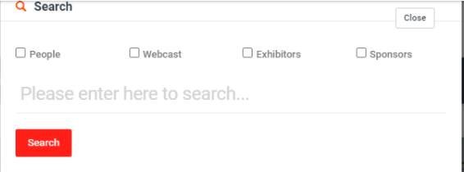

You can also navigate around the virtual event by using the Search feature located at the to of your screen. Search by specific people, webcasts, exhibitor company, or sponsor company.
Setting Meeting Times
- The search function highlighted above is also how you will set up one-on-one appointments with exhibitors.
- Navigate to the search at the top of the event screen (shown above).
- Check off “people” then use the search field to type in the company name.
- Select a name from the exhibitor staff list (they are all looking forward to engaging, so choose any name!).
- You will then be prompted to send a message within the platform. Customize the date and time you would like (meetings are set in 10 minute increments).
- You will then receive a message in the system and an email sent directly to your inbox.
- Once your meeting time comes up simply navigate to the exhibitor booth. The exhibit staff you chose will be there waiting. Simply hit “Start Video Chat” and select their name.

Tip: Make sure to block off this time in your calendar so you will get a reminder.

We look forward to seeing you there!
Okay we’ve checked the basics. Now, let your peers know how excited you are about the AAGC2020 by sharing via social media and/or email. #AAGC2020

If you have any questions, the Virtual Event Place has an online support chat tool managed by real people that can help you during show hours, or 9am-5pm EST during non-show hours.

Additional Tips
- Have a hardwired internet connection (prevents unstable WIFI issues)
- Mute your microphone when not talking
- Try to avoid talking over / at the same time as other participants
- When you start video chat, be aware you are on camera and try to avoid doing other tasks, checking emails, looking at your phone etc.

